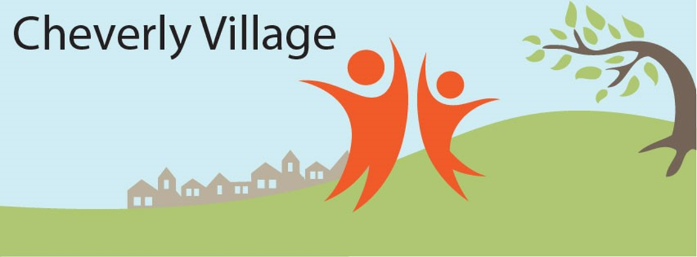
NOVEMBER 2020 EVENTS FOR MEMBERS, VOLUNTEERS AND FRIENDS

NEW! Events on Demand can be found in the drop-down tab of EVENTS on the Cheverly Village website. You can find community offerings to access at your convenience, such as live concerts by The Marine Corps Band and YouTube videos of their past performances, plus online events from the Prince George’s County Memorial Library System (PGCMLS) and the Smithsonian. Please share suggestions for online activities that you have found enjoyable as we work to expand this list. https://cheverlyvillage.helpfulvillage.com/pages/10028-events-on-demand

Explore the events below and register at https://cheverlyvillage.helpfulvillage.com/events/index_list. Events are frequently added during the month, so check back later to see what’s new.

Village Happy Hour, every Friday, 5:00-6:00 pm: Everyone is welcome! Invite friends.

Poet Richard Blanco in Conversation, Sunday November 1, 8:00 pm. Sponsored by PGCMLS.

Movies@hope, Friday, November 6, 7:30 pm: Slay the Dragon is a compelling documentary from 2019 that shines a spotlight on the practice of political gerrymandering. Visit Hope Lutheran Church’s website, hope.cp.org, for Zoom information.

East of the River in concert, Friday November 6, 8:00 pm: Live, streamed early music concert. Sponsored by Capitol Early Music.

Shifting Dynamics of the Middle East, Israel, & Its Neighbors, with Michael Sharnoff, November 9, 1:00-2:30 pm. Sponsored by Little Falls Village.

Tea and Tech, Tuesday, November 10, 2:00-3:00 pm: Bring your perplexing tech issues for resolution with help from the Village’s tech savvy volunteers.

Cheverly Village Book Club, Wednesday, November 11, 2:00-4:00 pm: Gray Mountain by John Grisham will be discussed. First-timers, please email Events@cheverlyvillage.org for the Zoom invitation. You can also phone into the discussion—call 301 715 8592 and provide the Meeting ID number when prompted followed by the # sign: 926 394 3660 #

Birth of Rationality and Roots of our Civilization, Thursday, November 12, 8:00-9:00 pm: Talk by Pierre Larrouque. Sponsored by Little Falls Village.

BINGO Online, Tuesday, November 17, 2:00-4:00 pm: Enjoy a mix of socialization and the “fun & games” of winning a prize! No computer, no problem--you can call into the Zoom game at 301 715 8592. When prompted, provide this Meeting ID number (926 394 3660) followed by the # sign.

Ready, Set, Bank, Part 1 and Part 2 (for adults over 50), Tuesday and Thursday, November 17 & 19, 2:00 pm: A $50 gift card will be awarded for attending both sessions. Sponsored by PGCMLS. Email shelley.Obrien@pgcmls.info to register. Spanish speakers, email Lance.Lambert@pgcmls.info to register.

Coffee Chat, Tuesday, November 24, 2:00-3:00 pm: Have Do-It-Yourself (DIY) projects kept you busy during these past months at home? Share experiences with your fellow Village members over a cuppa tea, coffee, or hot cocoa. Bring your ideas for future chats.

COMMUNITY EVENTS

ELECTION DAY! Tuesday, November 3.

Cheverly Community Market, Saturdays, November 7 and 21, 8:00 am-noon. More details and preorder info at https://www.cheverlycommunitymarket.org.

www.cheverlyvillage.org

Contact us: Village@CheverlyVillage.org (240) 770-1033

